The Macedonian Wars
THE FIRST MACEDONIAN WAR by (United Nations of Roma Victrix, 2025a)
Share Tweet Share Pin Share As Hannibal ravaged Italy in the Second Punic War, Philip V of Macedonia sought to take advantage of Rome's problems and extend his domain within his region of influence.
After Hannibal destroyed the Romans at Cannae in 216 BC, the opportunity was perfect for an alliance between Philip and Hannibal. Heavily influenced by Demetrius of Illyria, who had been expelled by the Romans just a few years earlier, Philip looked to both the north and south to expand his kingdom.
Macedonia and the Aegean region c. 200 BC
In 214 BC, Philip moved a small fleet to Illyria to begin feeling out his chances there. The Romans, with little resources to spare for another major campaign, sent the Praetor Marcus Valerius Laevinus with a fleet of 50 ships to watch over Philip from Apulia on the Adriatic. As Philip campaigned in Illyria, Laevinus crossed over to protect Roman interests, and Philip was forced to burn his small fleet to prevent its capture.
Philip, however, was not to be so easily defeated. Well aware of Hannibal's victories in Italy, he knew that Laevinus could only defend by sea, and so the land route to Illyria was wide open. Marching north, the Macedonians captured several cities, while all Laevinus could do was prevent any attempted reinforcement of Hannibal's Carthaginian army and harrass coastal bases and supply routes.
The Roman Senate had no choice but to seek land allies within reach of Philip to counteract Macedonia. In 211 BC, the Romans approached the Aetolian League of West Central Greece - old enemies of Philip - to form an alliance. A deal was struck easily, granting the Aetolians any land they could capture simply in exchange for keeping Philip occupied.
Initially, the Aetolians were successful... at least, successful enough in the Roman view to accomplish the objective of keeping a buffer between Philip and Italy. In 209 BC, the small alliance was joined by Attalus of Pergamum on the Asia Minor coast, but nothing of any major consequence came of this arrangement other than, again, helping to keep Philip at bay.
By this time, Publius Sulpicius Galba had taken command of the Adriatic fleet. His primary goal was to maintain the status quo while Rome dealt with Carthage.
An uneventful campaign year later, Attalus withdrew back to Pergamum with little gain or loss in the affair. By 208 BC, now free on his eastern flank, Philip invaded the Aetolians without their ally and little available assistance from Rome, forcing Aetolia to sue for peace.
Despite Galba's objections, the Aetolians were outmatched, and by 206 BC were ready to accept Macedonian terms. Philip continued to have his way on the eastern shore of the Adriatic for another couple of years as the Romans waited out Hannibal back in Italy.
By 205 BC, Scipio's invasion of Africa forced the withdrawal of Hannibal back to Carthage, and Rome was able to finally deal with Philip. Tired of the long and terribly costly Second Punic War, however, the Romans did little more than assemble an army.
11,000 legionaries were assembled from Punic War veterans and prepared to meet the Macedonians but, by this time, both sides were ready for peace. Philip was happy with his gains and was willing to negotiate peace if the terms were favorable, thereby avoiding direct confrontation with Rome's veterans.
Near the end of 205 BC, Scipio Africanus treated a peace arrangement with Philip that allowed him to keep almost everything he had gained. The interior regions of Illyria (previously only of nominal interest for Rome) was ceded willingly to Macedonia, and access to the Adriatic Sea was also granted. Greek cities on the western coast of the Achaean peninsula, however, had to remain free of Macedonian authority, and with this Philip willingly agreed.
With little cost or effort in the so-called "war", the Romans gave up very little of their own properties or territories, and achieved their goal of keeping Philip from helping Hannibal. Because of its treaty arrangement working to the benefit of the Greek city-states, Roman influence in the cultural center of the world deepened and became more profound.
The close relations between Rome and Greece, along with continued resentment between Rome and Macedonia, would lead to a series of several wars between the two nations.

The Second Macedonian War by (United Nations of Roma Victrix, 2025b)
Share
Tweet
Share
Pin
Share
Since the treaty between Rome and Macedonia in 205 BC after the conclusion of the First Macedonian War, the two nations maintained an uneasy and fragile peace.
Rome was still occupied with Carthage, ending the war with the victory over Hannibal at Zama in 202 BC, and the continued hostile actions of Philip V of Macedon had to be temporarily overlooked. During the interim period between the First and Second Macedonian Wars, Philip took full advantage of Rome's apparent indifference.
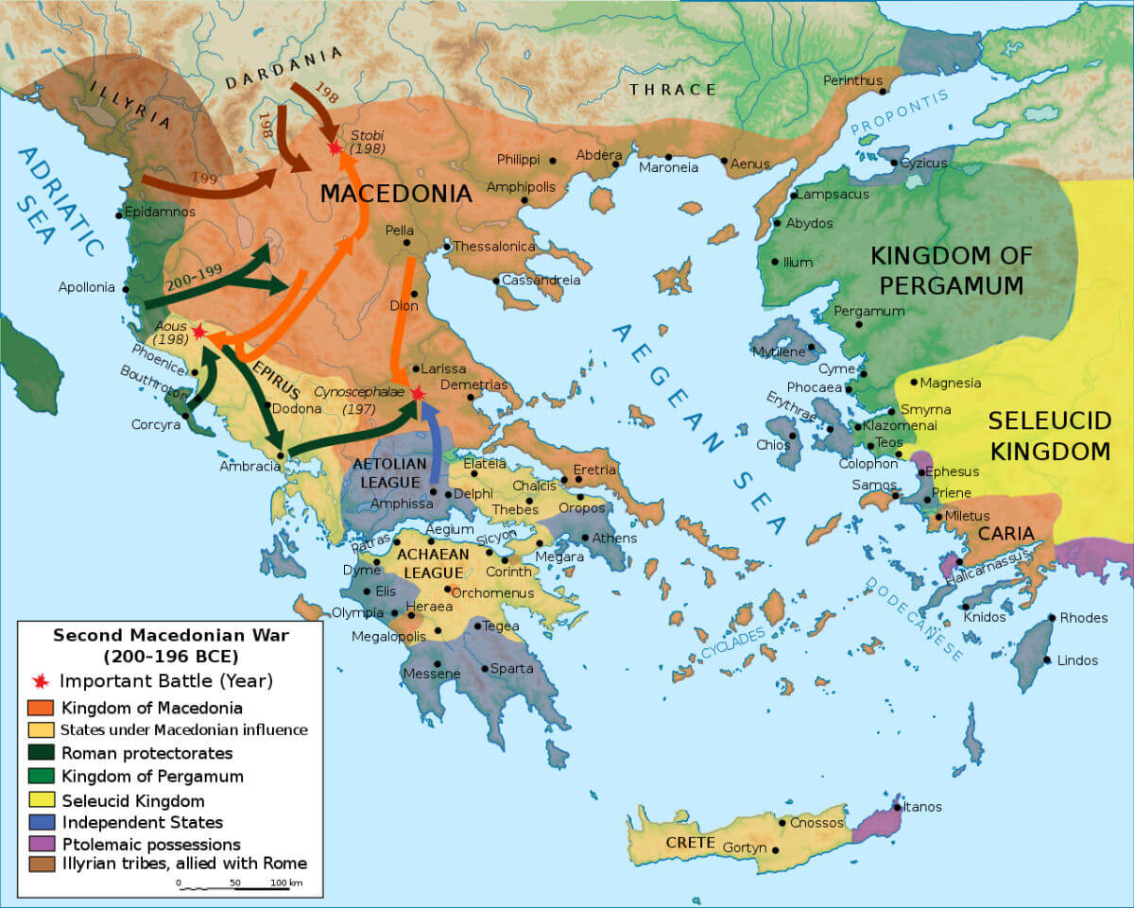
Pasztilla aka Attila Terbócs, Marsyas, WillyboyDerivative work: Amphipolis, CC BY-SA 4.0, via Wikimedia Commons
A map of the campaigns and battles of the Second Macedonian War

By 203 BC, Philip - having won some lands in Illyria during the first war - pressed his advantage in the region by gaining more territory in the Roman protectorate. Roman objections eventually changed Philip's tack, but moved him closer towards new conflict with Rome. He stretched his influence into the Greek cities to his south rather than Illyria in the north, which were formerly considered under the protection of Rome.
In 202 BC, Philip and Antiochus III of Syria entered into a secret deal to expand their own territories. The goal was to divide up the possessions of the Egyptian monarchy, which was embroiled in civil strife and under the rule of the child king, Ptolemy V. Antiochus moved against southern Syria and other parts of the current Middle East, while Philip turned away from Roman aggression to his west. His target was Thracia, and control of the important shipping lanes from the Black Sea to the Mediterranean.
By 201 BC, Philip was fully at war with the powerful fleet of the island-nation Rhodes, and with Attalus, King of Pergamum, in Asia Minor. Losses in battle to these nations inspired the Greeks, who had fallen under Macedonia's control, to rise up and appeal to Rome for help. A diplomatic mission from Pergamum, Rhodes and Athens arrived in Rome in the same year, all with the same goal of securing Roman intervention.
While initially rejected by the Senate, it soon became clear that Philip had to be dealt with, either in Macedonian territory at that point, or later after potentially building enough strength to invade Italy. Ambassadors were sent to Philip demanding his withdrawal from the territories of Rome's allies, which were flatly rejected.
By 200 BC, Philip sent one army to invade Attica, a territory belonging to Athens, while he commanded a force against coastal towns in Thracia. Further rejection of Roman demands to cease and desist prompted the declaration of war. Rome's stated reasons were to secure the independence of the Greek cities, but certainly also with the subversive goal to expand Roman influence in the east. In the same year, the Roman Consul, Galba, took command of two legions, and the Second Macedonian War began.
Late in 200 BC, Galba raided Macedonian border towns and moved to Illyria to undo some of Philip's gains there. A fleet was sent around the Greek coast to help them fend off Macedonian sieges, and the Aetolians were convinced to once again join the Romans against Philip.
Otherwise, the early campaign was rather uneventful, with neither side gaining much of an advantage. Galba and his successor, Publius Villius Tappulus, essentially spent two years in a virtual stalemate.
Titus Quinctius Flamininus ascended to command the Romans in 198 BC, and immediately set about taking the war to Philip. In negotiating with the Macedonian King, Flamininus championed the freedom of the Greek cities and demanded Macedonian withdrawal from all of Greece. Obviously refused, Flamininus did win the desired outcome... the entry of the Greek Achaean League into the war as allies of Rome.
Flamininus then engaged Philip at the River Aous and won a minor engagement which opened up an invasion route to Thessaly. With the avenue now open, the Romans moved into Macedonian territory and laid siege to several towns, until winter forced him to retire at Phocis until the spring.
Again the two parties met for negotiations late in the year 198 BC. Flamininus used his political savvy to set himself up for either future campaigning, or to end the war. Had he lost his Consular powers at the end of the year, and terms could have been negotiated to end the war, but if he won re-election, he wished to continue the fight.
Delaying Philip in the discussions, he had the Macedonians send an envoy to Rome to discuss the exact terms of peace. However, while the envoy was en route, Flamininus learned that he would in fact be keeping his Consular powers for the next season, and 'arranged' for the peace negotiations to fail in the Senate due to lack of popular support.
Newly inspired by his chance to win the war on the battlefield, rather than in the Senate, Flamininus set about planning for the next campaign.
Opening the spring campaign, Flamininus led his two veteran legions - along with a strong compliment (8,000) of mostly Aetolian Greeks - into Thessaly. Philip responded to the conquest of several of his regional towns by confronting the Romans with about 25,000 men. The two armies met at Cynoscephalae in 197 BC.
In the first large-scale meeting between the Roman Republican legions and the classical Macedonian phalanx, the legionary flexibility proved superior. Hemmed in by their own rigid tactics, the Macedonians were overwhelmed as Flamininus countered Philip's tactics with various strategic maneuvers. With a crushing defeat, Philip had no choice but to settle on unfavorable terms.
By the year 196 BC, the terms of the treaty were negotiated, and Philip had to give up all claims on Greek territory, sending the city-states into the protectorate of Rome. He also had to pay 1,000 talents in gold as tribute. He was, however, left in command of Macedonia. The Romans viewed Antiochus III in Syria (and who was now expanding in Asia Minor) as a considerable threat, and they viewed Philip as a capable leader able to provide a buffer. Terms of the treaty also included that all Greek cities in Asia Minor were now under the protection of Rome, clearly aimed at thwarting Syrian expansion into that territory.
Rome, so soon after the end of the Second Punic War and with limited available manpower, wasn't able to continue to garrison the Greek cities, but the politically astute Flamininus used this fact of military necessity to Rome's advantage. At the Isthmian games in Greece in the summer of 196 BC, Flamininus announced the 'treaty of freedom'. Greece would be un-garrisoned by either Rome or Macedonia and they would be free to live their lives under their own laws and customs.
Winning great admiration from the Greeks that would last for centuries, Flamininus also accomplished another important goal. Unable to garrison the Greeks themselves, Greek admiration and gratitude to Rome for its part in defeating Macedon would secure their friendship and loyalty.
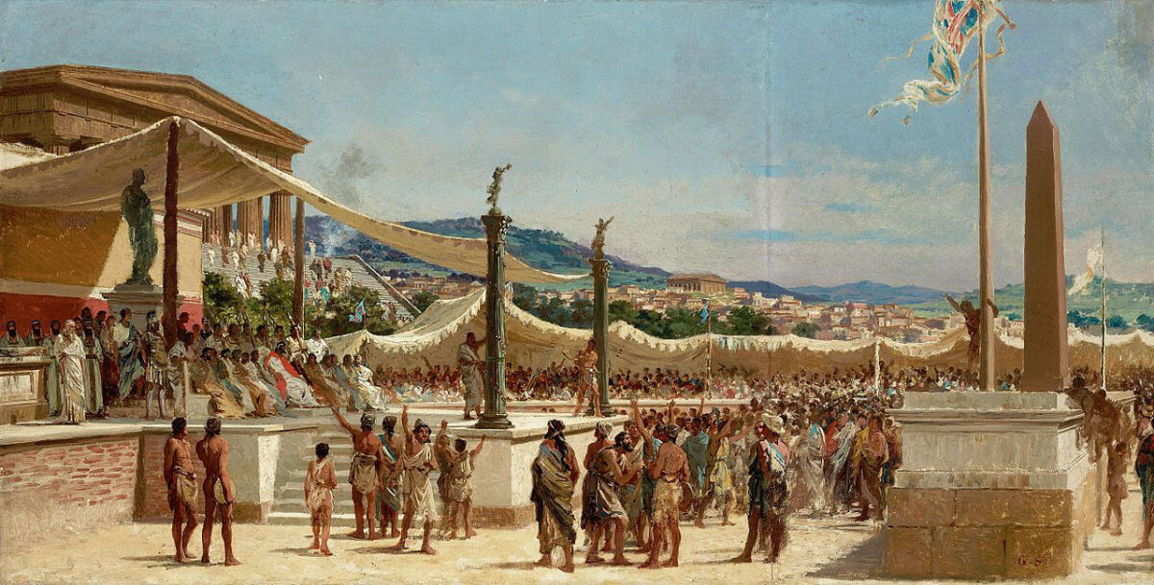
"Titus Quinctius offers liberty to the Greeks" by Giuseppe Sciuti, c.1879

Avoiding the quagmire of Greek politics, Rome expanded its influence in the east without the need for permanent legionary garrisons. By 196 BC, the Romans had removed all of their forces from Greece, while essentially gaining an obedient client kingdom and all the corresponding tribute that went along with it.

The Third Macedonian War (United Nations of Roma Victrix, 2025c)
Share
Tweet
Share
Pin
Share
After the Syrian War against Antiochus III, the Romans were not idle in the east, but the situation to their north and west took priority for some time.
In Cisalpine Gaul, rebellious Celts had to be put down once again, and the province was given a major overhaul in terms of roads, colonies and various infrastructure projects. Further west, in Hispania, trouble with the Turdenati and Celtiberians continued almost non-stop since the end of the Second Punic War.
The father of the famous Gracchi brothers, Tiberius Sempronius Gracchus, put a short-term end to the violence in 179 BC, but more problems were soon to come.
While Spain proved a difficult province to govern, the situation in the east was no better. Relations between Rome and Macedonia never improved since the end of the first two Macedonian Wars, and Philip V passed his dislike of Rome onto his son, Perseus.
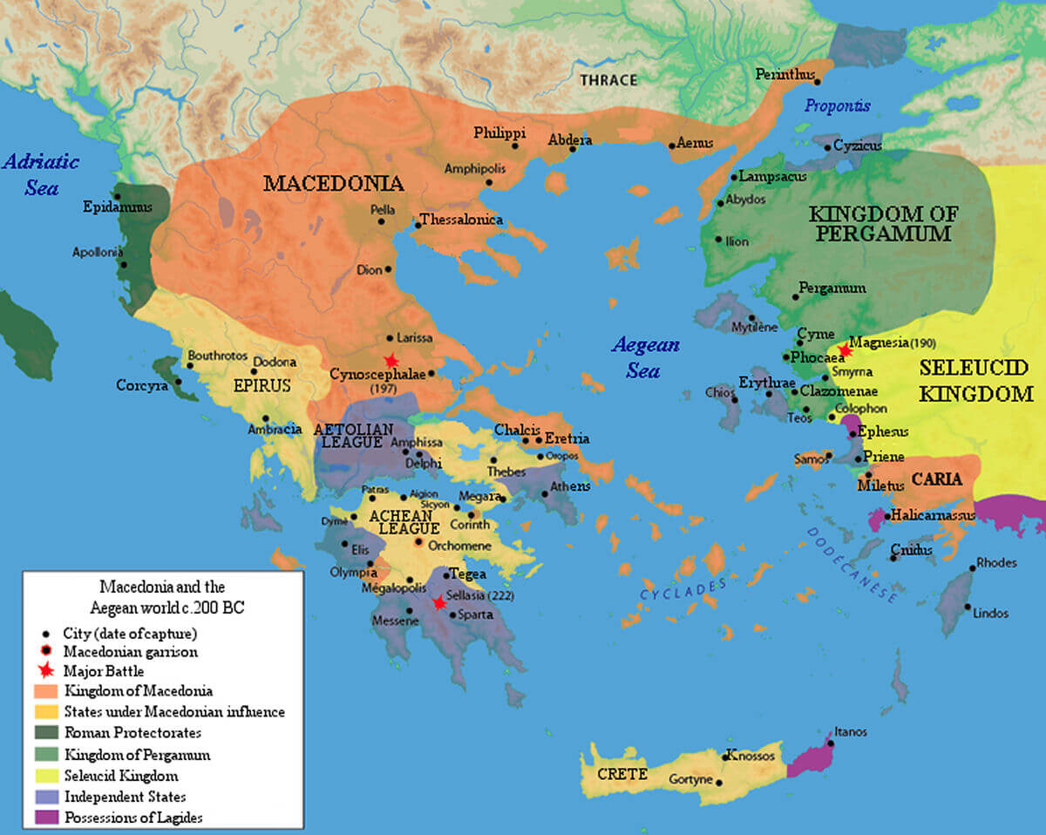
Macedonia and the Aegean region c. 200 BC

Perseus took the throne of Macedonia in 179 BC upon the death of his father, and immediately set about undermining regional Roman authority.
He arranged a marriage alliance with Antiochus III, an obvious enemy of Rome from the Syrian war, and instituted debt relief in his kingdom. This policy was upsetting to the Roman Senate and wealthy businessmen who supported the local governments, and would end up losing out financially because of this policy. Militarily, Perseus moved into territories north of Macedon and south into Greece, violating terms of earlier treaties confining Macedonia to its traditional frontiers. Finally, he attempted to re-establish relations with the Achaean league and other Greek city-states, threatening Rome's jurisdiction.
By 172 BC, Eumenes, King of Pergamum and a loyal Roman ally, began making accusations against Perseus that he was violating Pergamum's territory. Diplomatic relations went in favor of Perseus for the simple reason that the majority of the Senate was disturbed by the prospect of yet another war.
The winds of change wouldn't take long to alter Roman opinion, however, as a perceived assassination attempt on Eumenes, and continuing trouble in Illyria, were both attributed to Perseus. Roman reaction was swift, despite their consternation over yet another offensive war.
Legions were sent to Epirus to prepare Macedonian invasion routes, and diplomats were sent to various Greek cities to ensure their continuing support and loyalty. The Consul Quintus Marcius Philippus established himself on the Macedonian frontier, putting an end to any thoughts of open rebellion among the Boeotian League, a conglomerate of tribes allied to Perseus.
By the spring of 171 BC, war was declared, and the Consul for that year, Publius Licinius Crassus (not to be confused with Marcus Licinius Crassus who was in the triumvirate with Julius Caesar and Gnaeus Pompeius Magnus), moved a force to Thessaly, where he was defeated in a minor engagement.
He blamed the Aetolians, another thorn in the Roman's side since the war with Antiochus, and arrested several of their leaders. Praetors Gaius Lucretius Gallus (171 BC) and Lucius Hortensius (170 BC) sacked several enemy and allied Greek towns, inciting rage among the Greeks.
The war turned into a political internal struggle for the next several years as accusations, reparations and convictions were laid down upon corrupt Roman officers for their conduct towards allies. The Roman army was an undisciplined mass, growing fat and happy on plundering defenseless Greek towns, and the Consuls of 170 and 169 BC - Aulus Hostilius Mancinus and Quintus Marcius Philippus respectively - did little to actually bring the war to Perseus, and seemed rather content to plunder the province of whatever wealth they could gather.
168 BC finally proved to be decisive. Lucius Aemilius Paullus, Consul for the year, arrived and immediately set about training and organizing his army. Paullus managed to force Perseus to battle on 22 June 168 BC at Pydna. The Macedonians were caught on broken ground - disadvantageous to the immobile phalanx - and had little chance of victory.
The Romans slaughtered 20,000 of the Macedonian force, taking 6,000 prisoners and 5,000 from nearby forces. Perseus escaped the carnage, but his allies in the region quickly submitted to Rome and, without an army, he had no choice but to surrender. Perseus was paraded in Paullus' triumph and later banished to the small Italian town of Alba Fucens, where he lived the rest of his days in obscurity and miserable conditions.
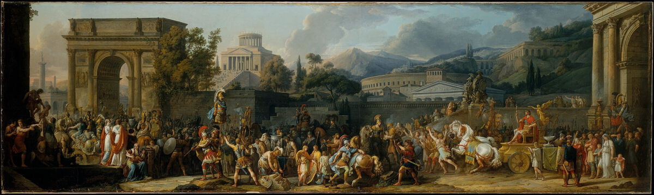
The Triumph of Aemilius Paullus by Carle Vernet (1789)

The Romans, however, weren't satisfied with only punishing Perseus. Too many local inhabitants jumped to Macedonia's aid whenever they started trouble, and it was time for it to end.
Macedonia was broken into four republics, where each was denied the right to conduct commerce with each other. Most local magistrates of any significance were removed from power and shipped off to Rome with Perseus. The Illyrian Kingdom of King Genthius, an ally of Perseus, was also broken up in a similar fashion.
The worst victim of the Roman victory, however, was Epirus. Paullus needed to make an example to the entire region of what would happen in the case of resisting Rome, and the aid Epirus provided to Perseus provided a perfect opportunity.
A resulting decree from the Senate authorized the plunder of the coastal region, and Paullus took full, and brutal, advantage. 70 towns in the territory were required to give up all the gold and silver they had in order to stave off Roman retribution. When the treasure was delivered, however, Paullus went back on his suggestion that providing the plunder would protect the inhabitants. He ordered an assault on all 70 of these towns, crushing the walls and capturing and slaughtering as many people as he could. The result was a massive slaughter in which countless lives were lost, and over 150,000 Epirotes were sold into slavery.

The Fourth Macedonian War and the Achaean War by (United Nations of Roma Victrix, 2025d)
Share
Tweet
Share
Pin
Share
Despite Rome's continual military success in Greece, Macedonia and against the Syrians, the political situation in the east remained largely unstable. The lack of a permanent presence of Roman legions allowed a certain level of independent thinking without fear of reprisal, and the appointment of corrupt and greedy Praetors to oversee the client states further fueled anti-Roman sentiment.
Cilician piracy was also a source of concern in the region, and the Romans did little to stop it. Pirates supplied slaves and contraband taken from Greek estates to Roman ports, fattening the pockets of the Senators and other influential Romans. The lack of support from the legions in this case certainly added to the thoughts of independence.
The resulting situation in the divided republics of Macedonia allowed for someone to fill the power void without Roman interference. In 149 BC, Andriscus, a pretender to the throne (which was abolished with Perseus) claimed to be a grandson of Philip V and son of Perseus. Without serious resistance from Rome or Macedonian locals, he reunited the four previously separated Republics and raised an army to prepare for the Romans.
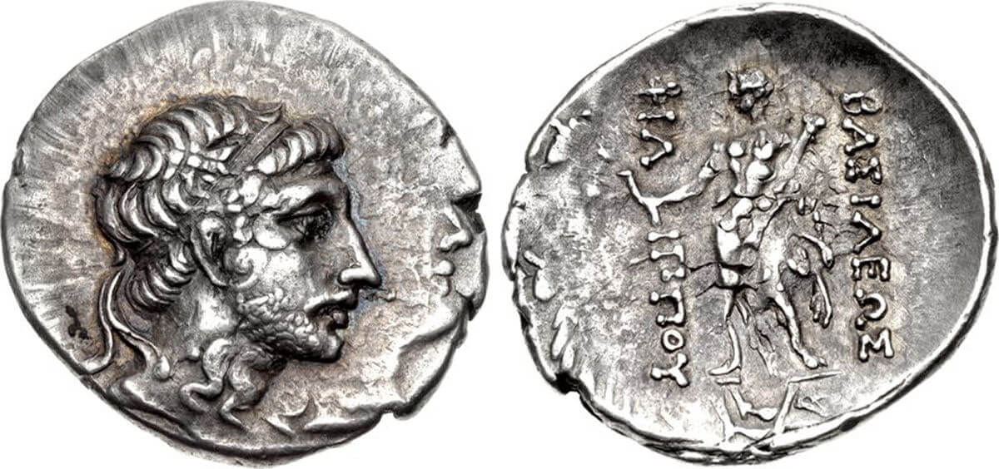
Classical Numismatic Group, Inc. http://www.cngcoins.com, CC BY-SA 2.5, via Wikimedia Commons
A drachm coin featuring Andriscus, overstruck on a Roman denarius coin

The first small force sent against him, under the Praetor Publius Juventius Thalna in 149 BC, was defeated, and Andriscus pushed his domain to include all of Thessaly.
The Senate, realizing that it was time to finally put an end to this unstable situation (while at the same time preparing to end any thought of Carthaginian resurgence), authorized a new army, commissioned under the Praetor Quintus Caecilius Metellus.
Metellus swiftly put down the revolt, and crushed any and all Macedonian resistance. By 148 BC, Macedonian independence had come to a complete end. Andriscus, his army destroyed, was forced out of the region. The Romans now officially made Macedonia, along with Epirus, their first eastern provinces, and Metellus was awarded the cognomen Macedonicus for his victories.
While Metellus Macedonicus was busy in Macedonia, however, the Greeks sought to take advantage, and led a semi-revolt of their own. Already in dispute with Rome over their annexation of Sparta into the Achaean league, and with pro-independence leaders in place, discord in the region continued.
Critolaus, one of these pro-independence leaders, was appointed dictator in Corinth, and Corinthian forces began incorporating several nearby city-states into its own territory. Envoys dispatched from Rome to bring order to the situation were mistreated and rejected. Once again, the Roman army was on the move.
Fresh from his victory in Macedon, Metellus moved south to quell these fresh Greek revolts. At Locris, Critolaus and his army were defeated, but Greek resistance continued. In 146 BC, Macedonicus had been recalled to Italy (to receive his cognomen) and the Roman forces were put under the command of Lucius Mummius (later Archaicus for his deeds in Greece). Mummius led a successful and brutal campaign, crushing the Greeks wherever he faced them.
The Leagues of the Achaeans, Phocians and Boeotians were all shattered, and resistance of the Greek people to Roman rule was put to an end. To teach them a lesson, Mummius was ordered to attack Corinth directly, as a show of force and to set an example (much like the fate Epirus faced for helping Perseus of Macedon at the conclusion of the Third Macedonian War).
Later that year, Corinth was besieged and eventually burned to the ground, with its captured inhabitants sold off into slavery. Weapons and armor of locals throughout the region were seized, and local militia activity was outlawed. While the Romans didn't yet incorporate Achaea into an official province, the governor of Macedonia was given formal charge of watching over the Greeks from that nearby proximity.
The original nations of the Hellenistic world were now a permanent part of the Roman Empire. The control of the entire Greek peninsula only took about 80 years, stemming from the initial political pressures of the Punic Wars, and required relatively minor military intervention.
The Romans, as they had done so many times in the past, and would continue to do for centuries, allowed their power of influence to keep opposing factions at war with each other, until such time as they were all ripe for complete subjugation.
Only a few years later, in 133 BC, this influence worked to the Roman's advantage again when Attalus III of Pergamum - a long-time Roman ally throughout these Macedonian, Syrian and Greek wars - ceded his Kingdom in Asia Minor to the Roman Senate.
This event, which not only granted Rome an extremely wealthy new province, provided the catalyst which would eventually open the entire east to Roman expansion and conquest.

